# Design Overview for <<Slide>>

Name: Klim Huynh

Student ID: 101634015

# Summary of Program

The purpose of the game is to help the player get from point A to point B. A major of the surface is ice, which is slippery and will not allow the player to stop moving until they have either hit the edge, an object or somewhere dry.

This is a rough overview of what the game will look like.

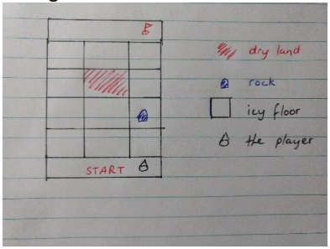

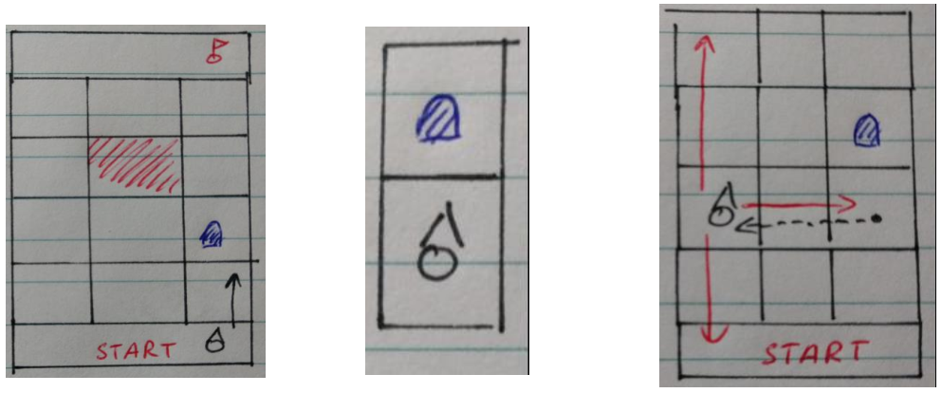The player will continue to slide through the direction the chose until they hit something.

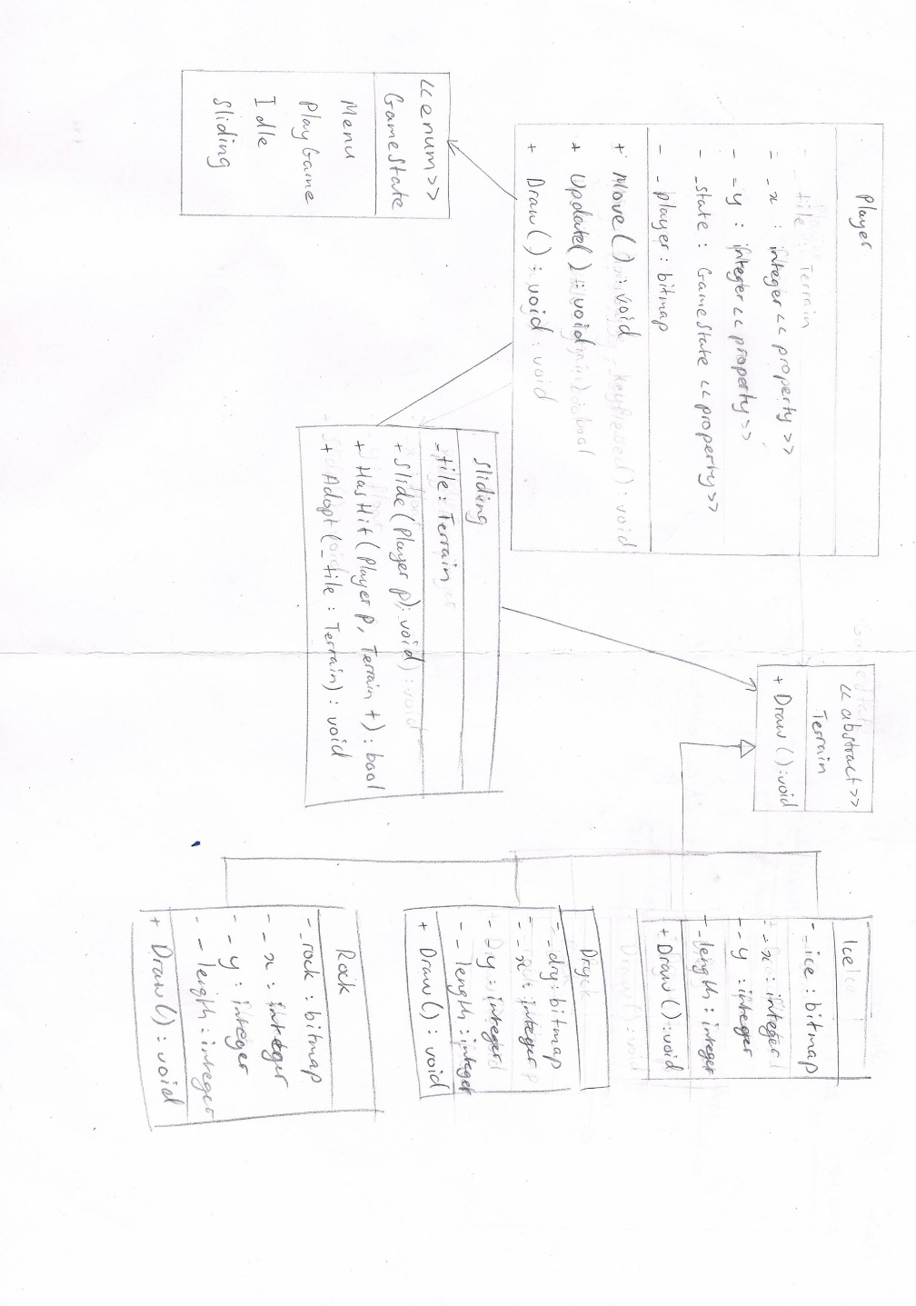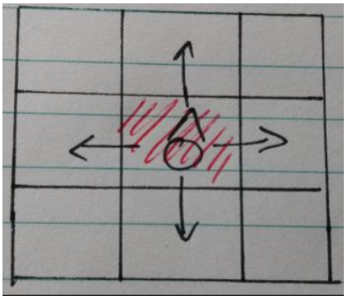

Hitting dry land will allow the player to stop and give them the option of sliding in a different direction.

UML Diagram

Sequence Diagram

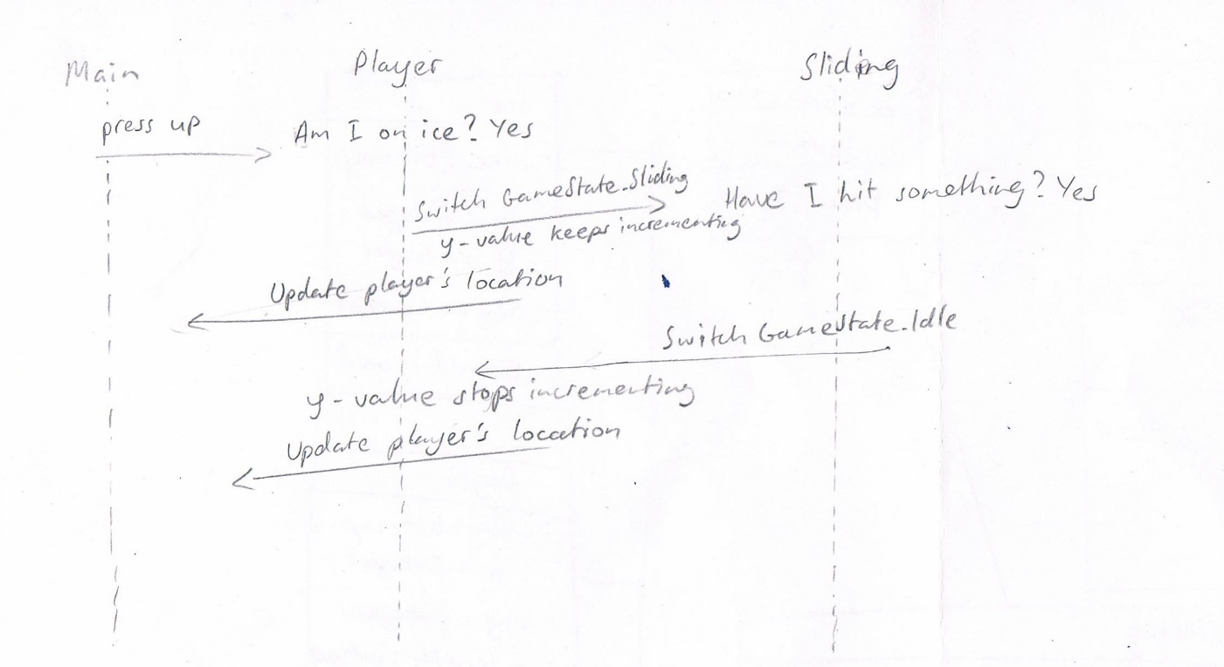

# Required Roles

Describe each of the classes and interfaces you will create using the following table (one per record).

Table : <<Player>> details

|  |  |  |
| --- | --- | --- |
| Responsibility | Type Details | Notes |
|  | Field type, parameter and return types |  |
| Player | Parameter: integer_x, _y  GameState _state = GameState.Idle  Bitmap _player;  Terrain _tile | This is the constructor. |
| X | Get {return _x;}  Set {_x = value;} | Read and write property |
| Y | Get {return _y;}  Set {_y = value;} | Read and write property |
| State | Get {return _state;}  Set {_state = value;} |  |
| Move |  | Switches the game state to sliding.  Passes player to sliding which moves the player. |
| Update |  | Update the player on screen, so you can see the player moving. |
| Draw | Parameter: integerx, y | Draw the player |

Table 2: <<Sliding>> details

|  |  |  |
| --- | --- | --- |
| Responsibility | Type Details | Notes |
|  | Field type, parameter and return types |  |
| Adopt | Parameter: Terrain t | Adds the different terrains and their x and y values into a list. |
| Slide | Parameter: Player p | Increments either the x or y value depending on which directional button is pressed |
| HasHit | Parameter: Player p, Terrain t | Checks to see if the player has hit any dry terrain or rocks.  If it has hit either dry terrain or rocks, switch the game state to idle, stopping the player from moving any further. |

Table 3: <<Terrain (abstract class)>> details

|  |  |  |
| --- | --- | --- |
| Responsibility | Type Details | Notes |
|  | Field type, parameter and return types |  |
| Terrain | Integer _x, _y | This is the constructor. |
| Draw | Integer _x, _y | Abstract method |

Table 4: <<Ice>> details

|  |  |  |
| --- | --- | --- |
| Responsibility | Type Details | Notes |
|  | Field type, parameter and return types |  |
| Ice | Base: (integer _x, _y)  Bitmap _ice | This is the constructor.  It inherits from terrain class. |
| Draw | Integer _x, _y | Draws the bitmap of ice at the coordinate |

Table 5: <<Dry>> details

|  |  |  |
| --- | --- | --- |
| Responsibility | Type Details | Notes |
|  | Field type, parameter and return types |  |
| Dry | Base: (integer _x, _y)  Bitmap _dry | This is the constructor.  It inherits from terrain class. |
| Draw | Integer _x, _y | Draws the bitmap of dry land at the coordinate |

Table 6: <<Rock>> details

|  |  |  |
| --- | --- | --- |
| Responsibility | Type Details | Notes |
|  | Field type, parameter and return types |  |
| Rock | Base: (Integer x, y)  Bitmap _rock | This is the constructor.  It inherits from terrain class. |
| Draw | Integer _x, _y | Draws the bitmap of a rock at the coordinate |

Table 7: << GameState enum>> details

|  |  |
| --- | --- |
| Value | Notes |
| Menu | Draw menu |
| PlayGame | Clear the screen and draw the game |
| Idle | Stops the player from moving.  Update the bitmap |
| Sliding | Depending on which direction only either the x-coordinate or y-coordinate changes.  Update the bitmap |